***POLO SHIRT299***

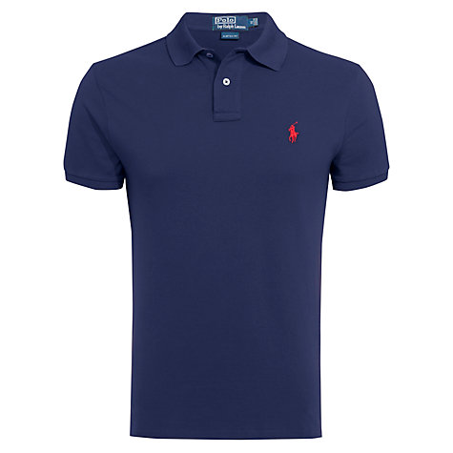

***DESCRIPTION:***

**POLO’S SHIRT MOST VALUABLE AND BEST SELLING PRODUCT ALL OVER THE WORLD.THEY ARE LOTS OF VARIOUS COLOR AVAILABLE IN MARKETS.IT HAS VERY SOFT.THEY ARE AVAILABLE IN EVERY SIZE.**